

Programme | : | M.Tech Int Software Engineering | Semester | : | Fall 2026-2027
Course | : | Database Systems Lab | Code | : | IASWE206
Faculty | : | Dr. M. Premalatha | Slot | : | L31+L32

Ex. No. 5
Date: 03-08-2026
SQL Aggregation Function and date Function

Note:
LMS Submission Format [Word File]
Regno, name
Course code, course title
Slot
Faculty Name
Question
SQL Query – Text Format (Copy Paste)
Screenshot

Ex:
Question:
create a student table with attributes regno, name, mobno and dob with appropriate datatypes and sizes

Query:
SQL> create table student_mp(regno varchar(4), sname char(10), mobno number(10), dob date);
Table created.

Screenshot:

SQL> desc student_mp
Name Null? Type
----------------------------------------- -------- ------------
REGNO VARCHAR2(4)
SNAME CHAR(10)
MOBNO NUMBER(10)
DOB DATE
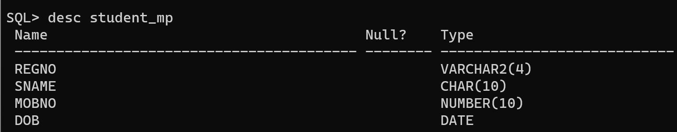

student(regno, sname, cgpa, school)
course(ccode, cname, credits)
faculty(empid, fname, designation, salary)
course_student(regno, ccode)
course_faculty(fid, ccode)

From the already created tables with key constraints of the above specified schema, write the SQL queries for the following:

- List the courses which have credits more than the average credits of all the courses.
- List the total salary of the faculty for each designation
- Name the faculty who receive the highest salary
- Specify the number of students who have registered for each course
- Name the faculty members with their designation who receive the salary more than the average salary of all the faculty members
- Name the student who have scored the minimum cgpa from smec school
- Count the number of students who have scored more than 6 and less than 8 cgpa
- Identify the school which has more than 3 students
- Specify the name regno of the students who have registered for more than 1 course.
- Add dob to student relation.
- Update the dob values for every record individually.
- List the students who are not born during “Jan” of 2012
- List the students whose age is greater than 18
- List the first three characters of all the students’ names
- If a student has less than 7 cgpa, increase his cgpa by 1
- List the students who are not born during December or November
- List the name of the faculty in capital
- Find the length of each designation
- List the course titles which has “data” in it
- List the students who haven’t born during Dec 2002

